## Signup Screen

Website URL : <http://www.diyaloo.com>

YouTube Link : <https://www.youtube.com/watch?v=_wYMOSoazJE&t=2s>

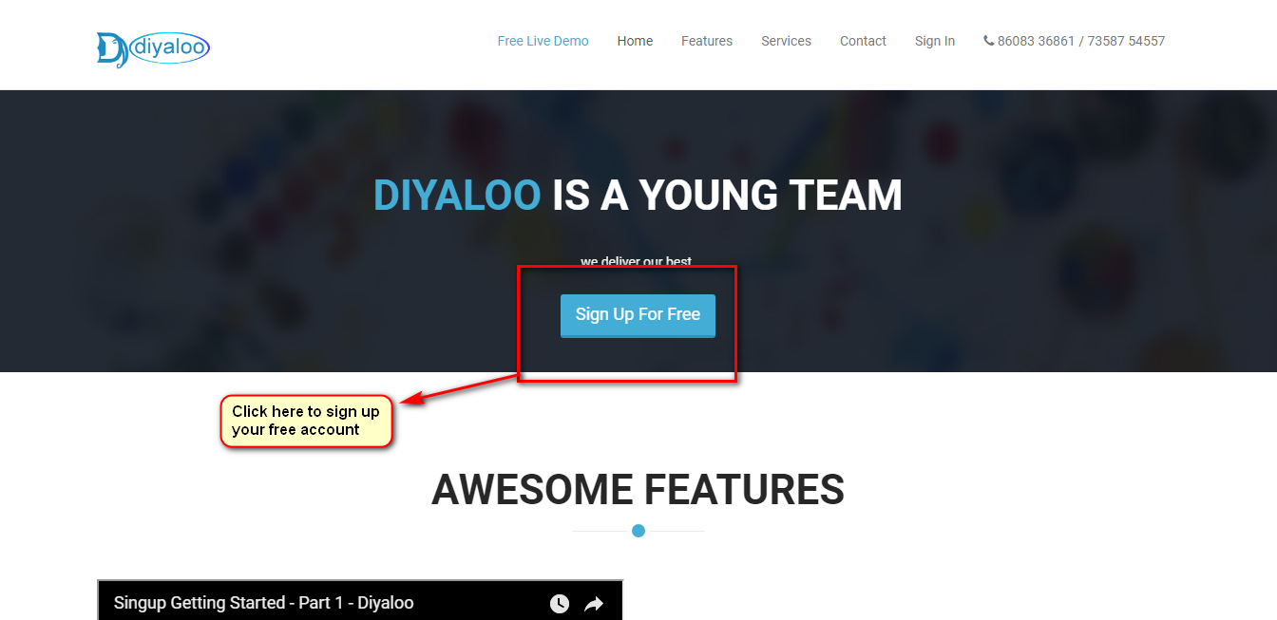

## User Registration

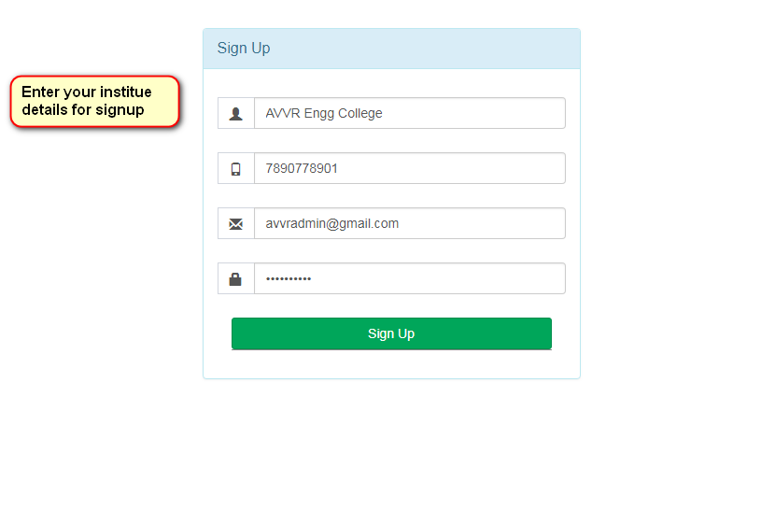

## After Signup

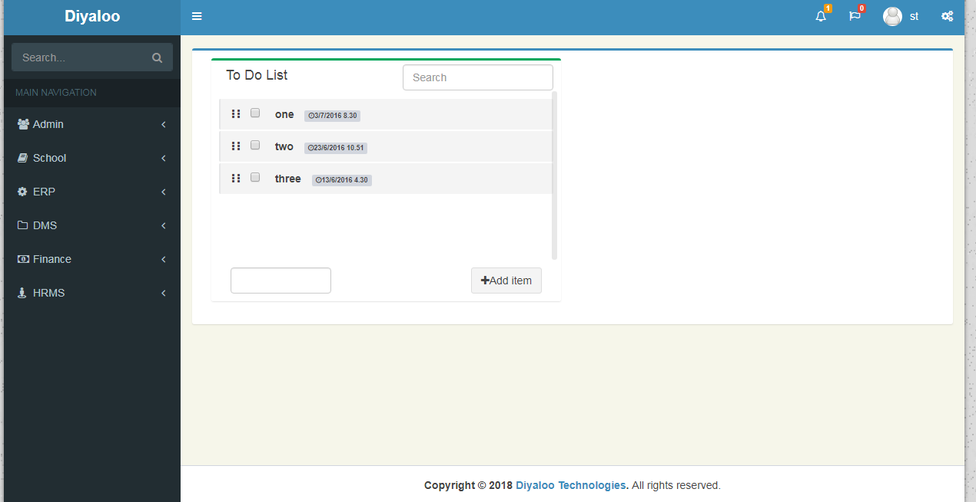

**To Sign In**

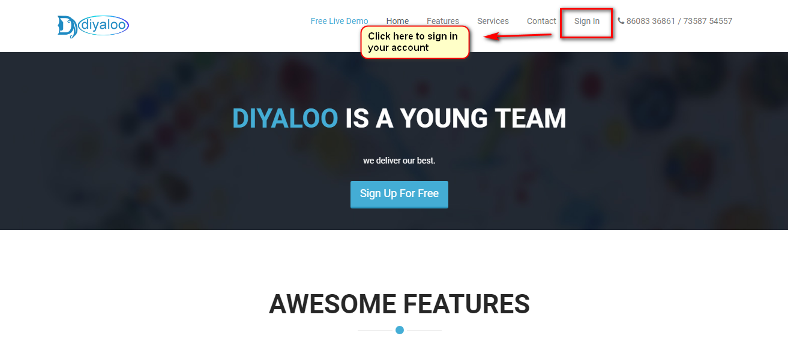

**Sign In Screen**

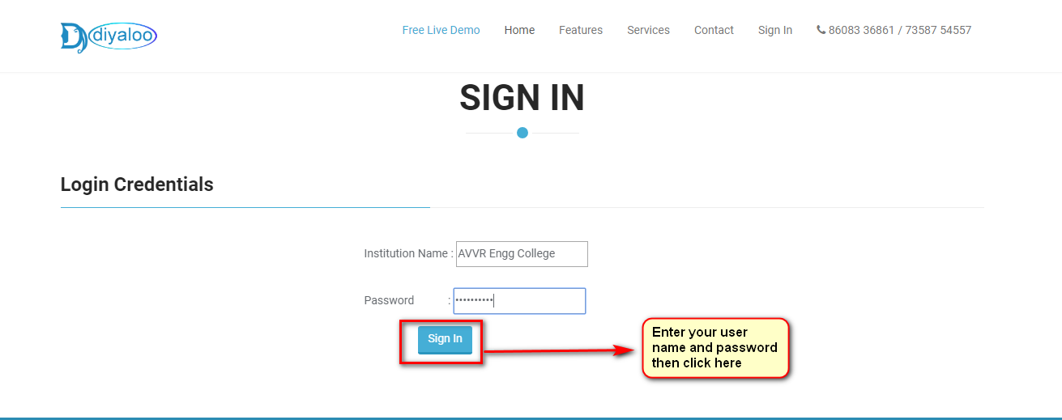

**After Sign In**

